THE ALPHABET RAP

Give me an A – A !
Give me a B – B !
Give me a C – D – E – F – G – G –G !
Give me an H – H !
Give me an I – I !
Give me a J – K – L and M – M- M !
Give me an N – N !
Give me an O – O !
Give me a P – Q – R – S – T – T – T !
Give me a U – U !
Give me a V – V !
Give me a W – X- Y – Z – Z !
Let’s snap, Let’s snap
Let’s clap, Let’s clap
Are you ready, are you ready,
For the Alphabet Rap ?
A B C D E F G
H I J K L M N O P
And Q R S T U V
W and X – Y – Z.
A B C D E F G
H I J K L M N O P
And Q R S T U V
W and X – Y
W and X – Y
W and X – Y – Z.
Yeah !
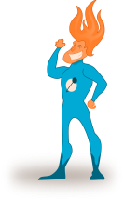
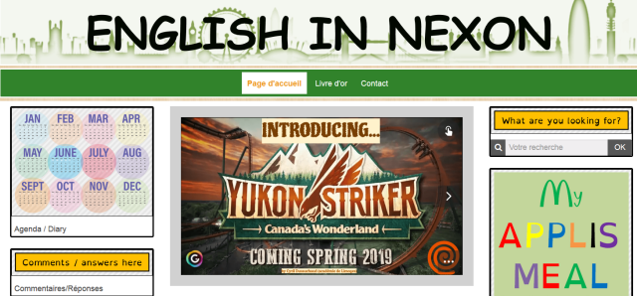
Je suis heureux de vous présenter mon site web, www.englishnexon.com. Sur ce site, vous pourrez consulter l'agenda mis à votre disposition pour planifier votre travail avant les évaluations, mais aussi réviser vos leçons, se préparer pour les évaluations, améliorer vos compétences écrites et orales, ou encore, m'envoyer différents travaux sous forme de fichiers vidéos, mp3, word ou pdf.
Je suis heureux de vous présenter mon site web, www.englishnexon.com. Sur ce site, vous pourrez consulter l'agenda mis à votre disposition pour planifier votre travail avant les évaluations, mais aussi réviser vos leçons, se préparer pour les évaluations, améliorer vos compétences écrites et orales, ou encore, m'envoyer différents travaux sous forme de fichiers vidéos, mp3, word ou pdf.

THE ALPHABET RAP

Give me an A – A !
Give me a B – B !
Give me a C – D – E – F – G – G –G !
Give me an H – H !
Give me an I – I !
Give me a J – K – L and M – M- M !
Give me an N – N !
Give me an O – O !
Give me a P – Q – R – S – T – T – T !
Give me a U – U !
Give me a V – V !
Give me a W – X- Y – Z – Z !
Let’s snap, Let’s snap
Let’s clap, Let’s clap
Are you ready, are you ready,
For the Alphabet Rap ?
A B C D E F G
H I J K L M N O P
And Q R S T U V
W and X – Y – Z.
A B C D E F G
H I J K L M N O P
And Q R S T U V
W and X – Y
W and X – Y
W and X – Y – Z.
Yeah !

